10 commandments of the digital world –
How can we live well together on the web

We live in a digitized world. We have a lot of freedom here, but also responsibility. How we behave and deal with conflicts is an expression of our ethical attitude. It is important to adhere to behavior so that a good, successful life in the digital society is possible.
Understanding the 10 commandments are guidelines that help to appreciate the dignity of the individual, his self-determination and freedom of action.
Let us respect them!

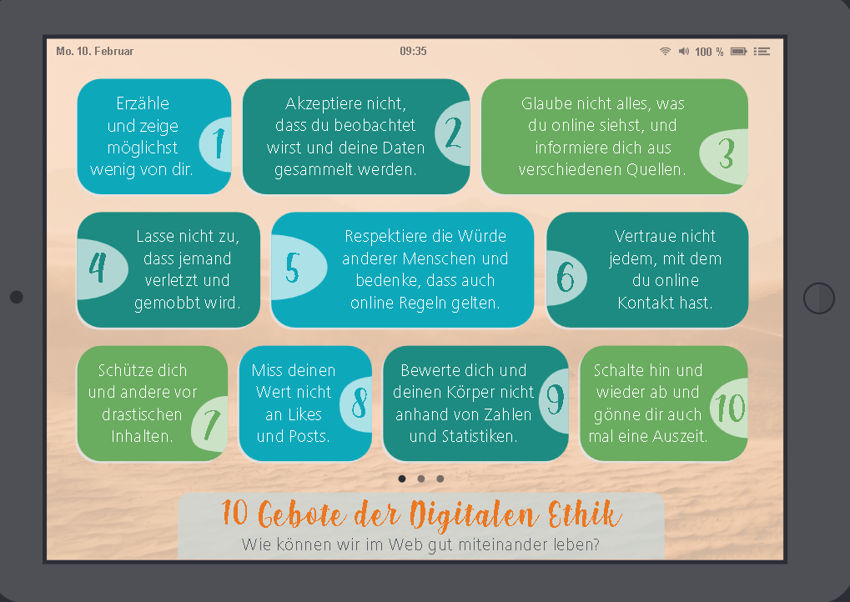

- Tell and show as little as possible about yourself
- Don't accept that you are being watched and that your data is being collected
- Don't believe everything you see online and do your research from various sources
- Don't let anyone get hurt or bullied
- Respect the dignity of other people and remember that rules also apply online
- Don't trust everyone you have contact with online
- Protect yourself and others from drastic content
- Don't measure your worth by likes and posts
- Don't judge yourself and your body based on numbers and statistics
- Switch off every now and then and treat yourself to a break

